MI349 Final Preproduction

Project: ReSpawn Used Games

By: Brendan Brockway

ReSpawn is a local game store that specializes in used games and vintage games. The website for ReSpawn has 3 pages: a homepage, an about page and a contact page. This pre-production document is used as a guideline for website iteration. This document contains:

* A pitch board
* A flow sheet
* 3 Wireframes
* A comp

Pitch board:

* Kept personas in mind while developing the site and the other preproduction steps.

Flows: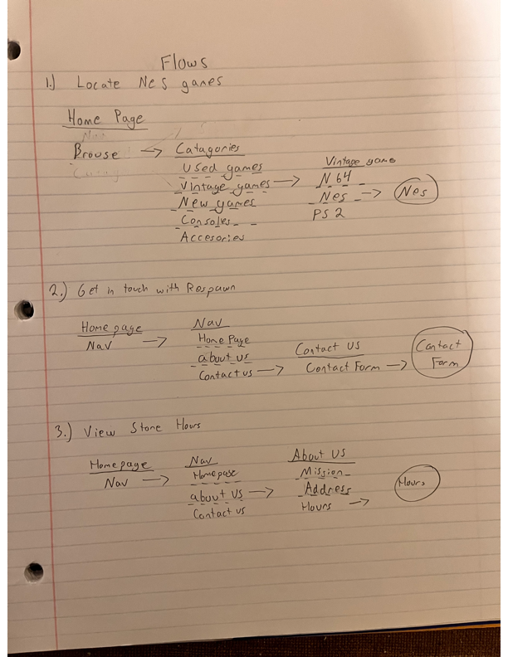

* Tried to limit the number of steps for users to get to any part of the site.
* Also tried to keep information clear and concise.

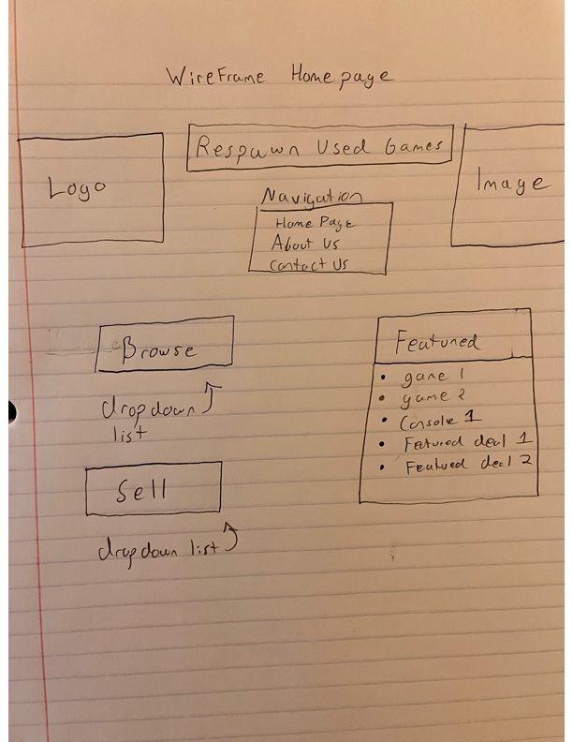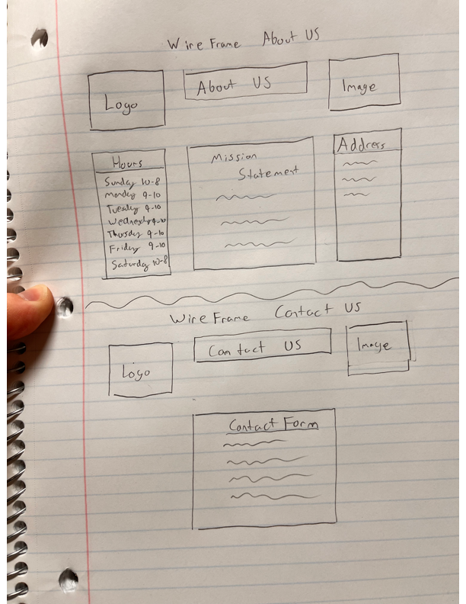Wireframes:

* Design of site is kept simple, only with necessary information.
* 3 pages on site: Homepage, about us and contact us.
* Uses drop down menus and a navigation list.

* Added copyrighting in the bottom of the page, about us and contact us pages will use the same color scheme and styling.
* Drop shadow applied to section boxes.
* Colors used:
  + 1E1E1E
  + 59ABD9
  + D9D9D9
  + ADE0FD